60” x 60” Drop-In

Model Number

**6060DPWR064**

**Right Hand Drain Whirlpool in White**

**6060DPWL064**

**Left Hand Drain Whirlpool in White**

Acrylic Whirlpool

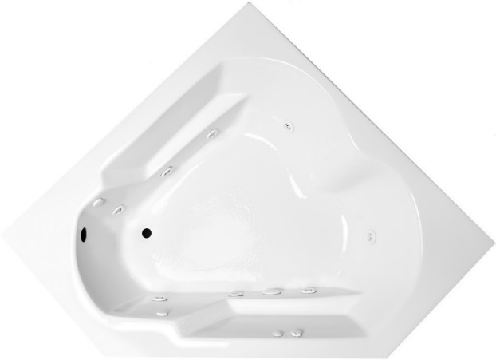

**Features**

* Color-matched jet trim
* 10 adjustable hydrotherapy jets
* Constructed of high-gloss durable acrylic
* 3-Speed control for the 13.5 Amp pump
* Inline heater available – LM300
* Mood light available – LM522
* Pre-leveled base for easy installation
* Made in the USA

**\*Dimensions are +/- 1/2” and subject to change without notice\***

**Confirm specifications before installation**

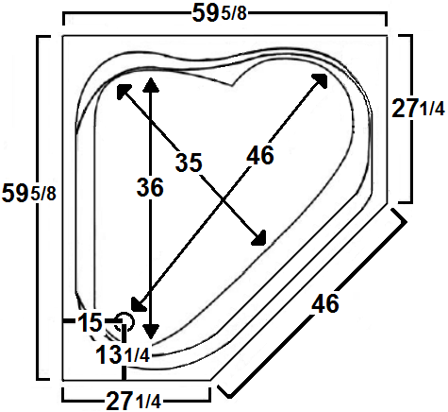

Standard (S) Pump Location

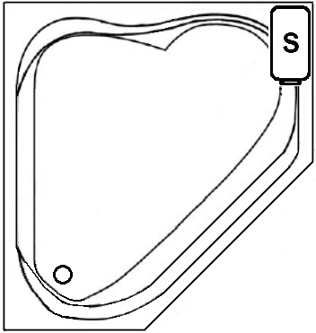

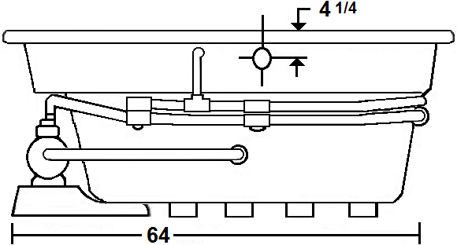

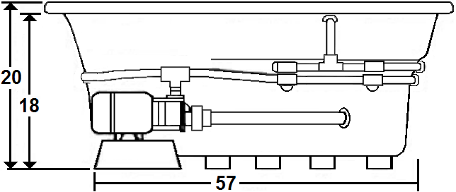

**Technical Information Electrical Requirements.**

* Standard Pump: 13.5 Amps
* (Optional) LM300 Heater: 12.0 Amps
* (Optional) LM509 Back Massage: 7.5 Amps
* (Optional) LM335 Ozonator: 1 Amp
* Dedicated GFCI’s required for each option
* Weight: 170 lbs.
* Water Depth to Overflow: 14 3/4”
* Water Operating Level: 48 gal.
* Water Capacity: 78 gal.
* Sump Dimension: 46” x 35”

*Cut-Out Dimensions: Use the outer dimensions shown above and come in 1” on all sides.

Laurel Mountain Whirlpools Customer Service: 1-800-930-0050 Email: sales@lmbath.com

**6060DPWR064**

**Right Hand Drain Whirlpool in White**

**6060DPWL064**

**Left Hand Drain Whirlpool in White**

**Whirlpool**

Experience a powerful, deep tissue therapeutic massage, which will soothe muscles & joints while releasing tension. Our eight standard, high performance jets will promote increased blood flow, improved flexibility and help reduce accumulated toxins.

Laurel Mountain enables you to enhance your bathing experience by offering a broad range of options to customize your bath. The options available on this bath are shown below.

**AVAILABLE OPTIONS & UPGRADES**

For Pricing, visit the “Help” page at www.laurelmountainwhirlpools.com. Download the Price book. For pictures and descriptions of options, go to www.laurelmountainwhirlpools.com and click “options” tab found at the bottom of the website.

**Therapeutic**

**LM300 Inline Heater** **BACK MASSAGE SYSTEMS**

**LM522 Chromatherapy** LM505 Chrome LM509 White

**LM500 Extra Jets (x2)** LM506 Brushed Nickel LM510 Biscuit

LM507 Bronze

**Accessories**

**TRIM KITS DEEP SOAK DRAINS 8” GRAB BARS**

LM101 Chrome LM200 Chrome LM230 White

LM102 Brushed Nickel LM201 Brushed Nickel LM231 Biscuit

LM103 Bronze LM202 Bronze

LM210 White **LM321 Electronic Control**

**LM335 Ozonator** LM211 Biscuit **Timer, & Variable Speed**

**(Sanitizing System)**  **Pump**

**Design / Construction**

**LM545 A-1 Pump Location LM557 Skirt (drain side) LM558 Skirt (non-drain side)**

**INSTALLATION**

Install this unit according to the Owner’s Manual. The Owner’s manual can be found by visiting the “Help” page at www.laurelmountainwhirlpools.com. Under “Relevant Links” on the left side of the page, click “Owner’s Manual”. Then click “Colony Owner’s Manual”.

Laurel Mountain Whirlpools Customer Service: 1-800-930-0050 Email: sales@lmbath.com