72” x 48” Drop-In

Model Number

**4872DW064**

**Drop-In Whirlpool in White**

Acrylic Whirlpool

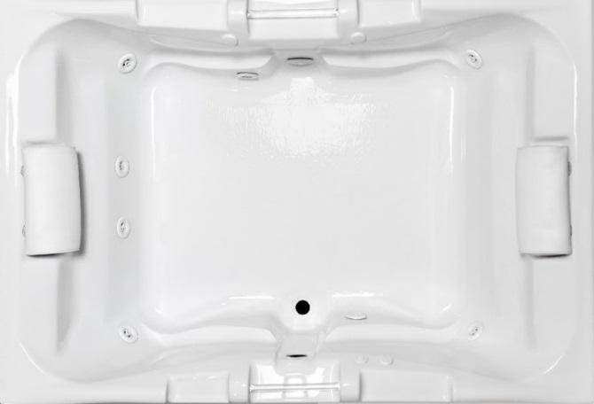

**Features**

* Color-matched jet trim
* 8 adjustable hydrotherapy jets
* Pillows included
* Constructed of high-gloss durable acrylic
* 3-Speed control for the 9.0 Amp pump
* Inline heater available – LM30
* Mood light available – LM522
* Pre-leveled base for easy installation
* Made in the USA

**\*All dimensions are +/- ¼” and subject to change without notice\***

**Confirm specifications before installation**

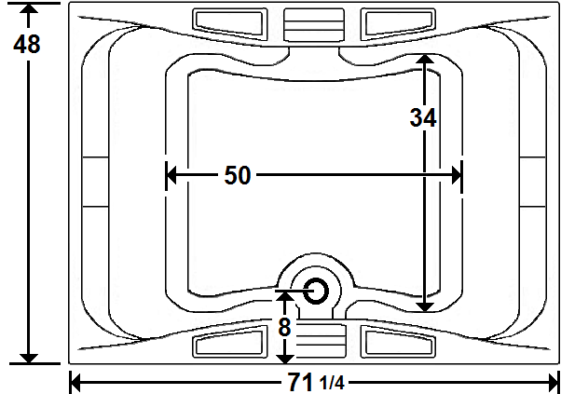

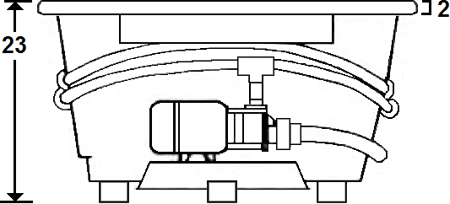

Standard (S) Pump Location and Alternate (A-1 & A-2) Pump locations.

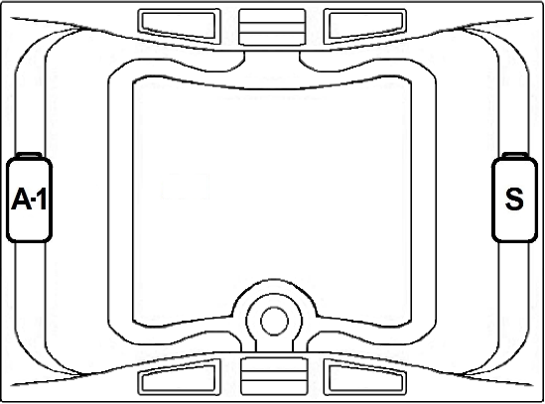

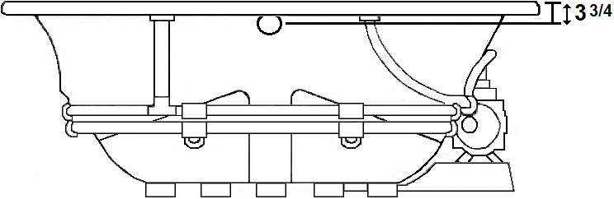

**Technical Information Electrical Requirements.**

* Standard Pump: 9.0 Amps
* (Optional) LM501 Pump Upgrade: 13.5 Amps
* (Optional) LM300 Heater: 12.0 Amps
* (Optional) LM509 Back Massage: 7.5 Amps
* (Optional) LM335 Ozonator: 1 Amp
* Dedicated GFCI’s required for each option
* Cut-Out Dimensions: 69 1/4” x 46”
* Weight: 210 lbs.
* Water Depth to Overflow: 16 1/2”
* Water Operating Level: 66 gal.
* Water Capacity: 115 gal.
* Sump Dimension: 50” x 34”

Laurel Mountain Whirlpools Customer Service: 1-800-930-0050 Email: sales@lmbath.com

**4872DW064**

**Drop-In Whirlpool in White**

**Whirlpool**

Experience a powerful, deep tissue therapeutic massage, which will soothe muscles & joints while releasing tension. Our eight standard, high performance jets will promote increased blood flow, improved flexibility and help reduce accumulated toxins.

Laurel Mountain enables you to enhance your bathing experience by offering a broad range of options to customize your bath. The options available on this bath are shown below.

**AVAILABLE OPTIONS & UPGRADES**

For Pricing, visit the “Help” page at www.laurelmountainwhirlpools.com. Download the Price book. For pictures and descriptions of options, go to www.laurelmountainwhirlpools.com and click “options” tab found at the bottom of the website.

**Therapeutic**

**LM300 Inline Heater** **BACK MASSAGE SYSTEM** LM509 White

**LM522 Chromatherapy** LM505 Chrome LM510 Biscuit

**LM500 Lumbar Jets** LM506 Brushed Nickel LM511 Almond

**LM501 Lumbar Jet Package** LM507 Bronze LM512 Linen

**LM515 Neck Massage Pillow** LM508 Polished Brass LM513 Bone

**Accessories**

**TRIM KITS DEEP SOAK DRAIN 8” GRAB BARS**

LM101 Chrome LM200 Chrome LM230 White

LM102 Brushed Nickel LM201 Brushed Nickel LM231 Biscuit

LM103 Bronze LM202 Bronze LM232 Almond

LM104 Polished Brass LM203 Polished Brass LM233 Linen

LM210 White LM234 Bone

**LM321 Electronic Control,** LM211 Biscuit

**Timer, & Variable** LM212 Almond **LM335 Ozonator**

**Speed Pump** LM213 Linen (**Sanitizing System)**

LM214 Bone

**Design / Construction**

**LM537 Bariatric/Heavy Duty LM545 A-1 Pump Loc**

**LM557 Skirt (drain side) LM558 Skirt (non-drain side)**

**INSTALLATION**

Install this unit according to the Owner’s Manual. The Owner’s manual can be found by visiting the “Help” page at www.laurelmountainwhirlpools.com. Under “Relevant Links” on the left side of the page, click “Owner’s Manual”. Then click “Colony Owner’s Manual”.

Laurel Mountain Whirlpools Customer Service: 1-800-930-0050 Email: sales@lmbath.com