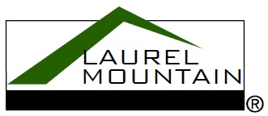60” x 36” Drop-In

Model Number

**3660MTA064**

**Drop-In Air Bath in White**

Acrylic Air Bath

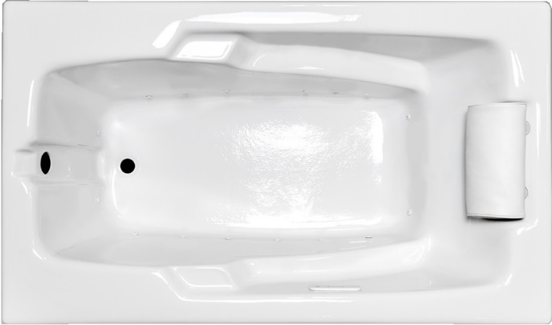 **Features**

* 16 high output lateral air jets
* Color-matched jet trim
* 12.0 Amp variable speed blower
* Pillow included
* Constructed of high-gloss durable acrylic
* Automatic purge cycle with timer
* Heaters available – LM305 & LM306
* Mood light available – LM522
* Pre-leveled base for easy installation
* Made in the USA

**\*All dimensions are +/- ¼” and subject to change without notice\***

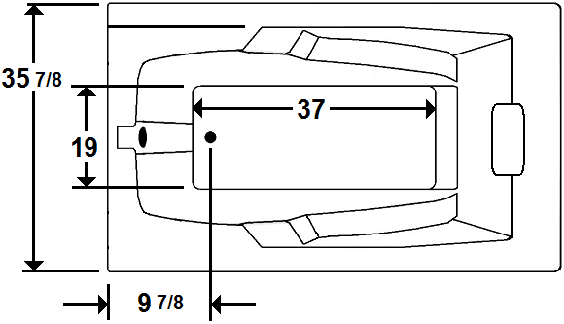

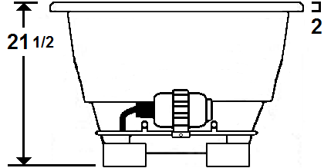

Standard (S) Pump Location and Alternate (A-1 & A-2) Pump locations.

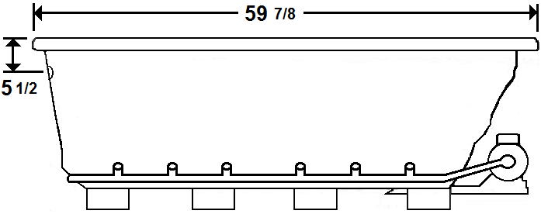

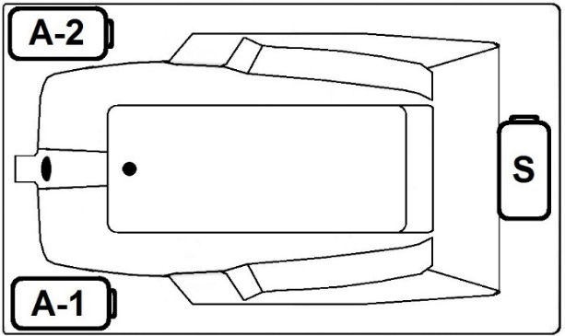

**Technical Information Electrical Requirements.**

* Standard Blower: 12.0 Amps
* (Optional) LM305 Heater: 12.5 Amps
* (Optional) LM306 Heater: 16.0 Amps
* (Optional) LM509 Back Massage: 7.5 Amps
* Dedicated GFCI’s required for each option
* Cut-Out Dimensions: 57 7/8” x 33 7/8”
* Weight: 135 lbs.
* Water Depth to Overflow: 16”
* Water Operating Level: NA
* Water Capacity: 58 gal.
* Sump Dimension: 37” x 19”

Laurel Mountain Whirlpools Customer Service: 1-800-930-0050 Email: sales@laurelmountainwhirlpools.com

**3660MTA064**

**Drop-In Air Bath in White**

**Air Bath**

Thousands of warm air bubbles provide an invigorating and yet relaxing, light, full body massage. The warm air movement increases blood circulation, soothes muscles and produces a feeling of well-being.

Laurel Mountain enables you to enhance your bathing experience by offering a broad range of options to customize your bath. The options available on this bath are shown below.

**AVAILABLE OPTIONS & UPGRADES**

For Pricing, visit the “Help” page at www.laurelmountainwhirlpools.com. Download the Price book.

**Therapeutic**

**LM305 12.5 Amp Water Heater (120V)** **BACK MASSAGE SYSTEM** LM509 White

**LM306 16 Amp Water Heater (240V)** LM505 Chrome LM510 Biscuit

**LM522 Chromatherapy Mood Light** LM506 Brushed Nickel LM511 Almond

**LM526 Aromatherapy** LM507 Bronze LM512 Linen

LM508 Polished Brass LM513 Bone

**Accessories**

**TRIM KITS SMALL GRAB BARS ROMAN TUB FAUCETS**

LM110 Chrome LM230 White LM600 Chrome

LM111 Brushed Nickel LM231 Biscuit LM601 Brushed Nickel

LM112 Bronze LM232 Almond LM602 Bronze

LM113 Polished Brass LM233 Linen **HANDSHOWER**

**DEEP SOAK DRAIN** LM234 Bone LM605 Chrome

LM200 Chrome **LARGE GRAB BARS** LM606 Brushed Nickel

LM201 Brushed Nickel LM240 White LM607 Bronze

LM202 Bronze LM241 Biscuit

LM203 Polished Brass LM242 Almond

LM210 White LM243 Linen

LM211 Biscuit LM244 Bone

LM212 Almond

LM213 Linen

LM214 Bone

**Design / Construction**

Laurel Mountain Whirlpools Customer Service: 1-800-930-0050 Email: sales@laurelmountainwhirlpools.com

**LM537 Bariatric/Heavy Duty LM542 Plastic Flange LM555 Skirt (RH drain)**

**LM540 Tile Flange (RH) LM545 A-1 Pump Loc LM556 Skirt (LH drain)**

**LM541 Tile Flange (LH) LM546 A-2 Pump Loc**