72” x 48” Drop-In

Model Number

**4872STA064**

**Drop-In Air Bath in White**

Acrylic Air Bath

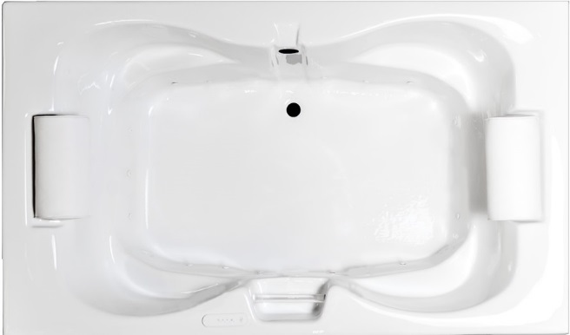 **Features**

* 16 high output later air jets
* Color-matched trim
* 12.0 Amp variable speed blower
* Pillow included
* Constructed of high-gloss durable acrylic
* Automatic purge cycle with timer
* Heaters available – LM305 & LM306
* Mood light available – LM522
* Pre-leveled base for easy installation
* Made in the USA

**\*All dimensions are +/- ¼” and subject to change without notice\***

**Confirm specifications before installation**

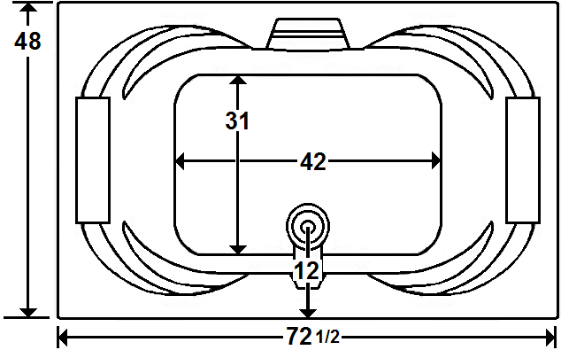

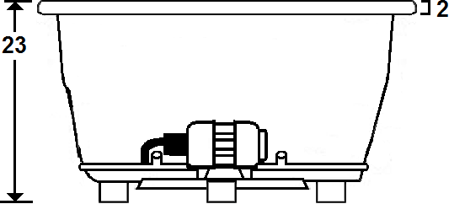

Standard (S) Pump Location and Alternate (A-1) Pump locations.

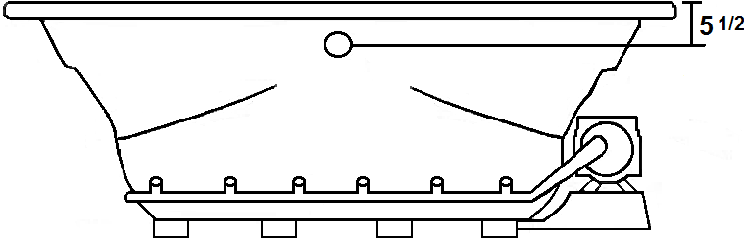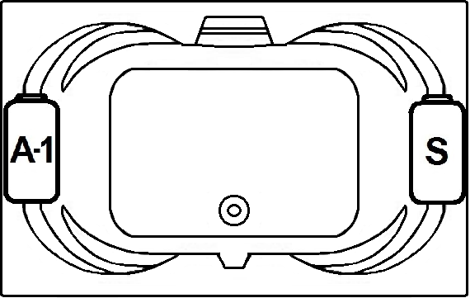

**Technical Information Electrical Requirements.**

* Standard Blower: 12.0 Amps
* (Optional) LM305 Heater: 12.5 Amps
* (Optional) LM306 Heater: 16.0 Amps
* (Optional) LM509 Back Massage: 7.5 Amps
* Dedicated GFCI’s required for each option
* Cut-Out Dimensions: 70 1/2” x 46”
* Weight: 200 lbs.
* Water Depth to Overflow: 17 1/4”
* Water Operating Level: 65 gal.
* Water Capacity: 112 gal.
* Sump Dimension: 42” x 31”

Laurel Mountain Whirlpools Customer Service: 1-800-930-0050 Email: sales@lmbath.com

**4872STA064**

**Drop-In Air Bath in White**

**Air Bath**

Thousands of warm air bubbles provide an invigorating and yet relaxing, light, full body massage. The warm air movement increases blood circulation, soothes muscles and produces a feeling of well-being.

Laurel Mountain enables you to enhance your bathing experience by offering a broad range of options to customize your bath. The options available on this bath are shown below.

**AVAILABLE OPTIONS & UPGRADES**

For Pricing, visit the “Help” page at www.laurelmountainwhirlpools.com. Download the Price book. For pictures and descriptions of options, go to www.laurelmountainwhirlpools.com and click “options” tab found at the bottom of the website.

**Therapeutic**

**LM305 12.5 Amp Water Heater (120V)** **BACK MASSAGE SYSTEM** LM509 White

**LM306 16 Amp Water Heater (240V)** LM505 Chrome LM510 Biscuit

**LM522 Chromatherapy Mood Light** LM506 Brushed Nickel LM511 Almond

**LM526 Aromatherapy** LM507 Bronze LM512 Linen

LM508 Polished Brass LM513 Bone

**Accessories**

**TRIM KITS DEEP SOAK DRAIN 8” GRAB BARS**

LM110 Chrome LM200 Chrome LM230 White

LM111 Brushed Nickel LM201 Brushed Nickel LM231 Biscuit

LM112 Bronze LM202 Bronze LM232 Almond

LM113 Polished Brass LM203 Polished Brass LM233 Linen

LM210 White LM234 Bone

LM211 Biscuit

LM212 Almond

LM213 Linen

LM214 Bone

**Design / Construction**

**LM537 Bariatric/Heavy Duty LM545 A-1 Pump Loc**

**LM557 Skirt (drain side) LM558 Skirt (non-drain side)**

**INSTALLATION**

Install this unit according to the Owner’s Manual. The Owner’s manual can be found by visiting the “Help” page at www.laurelmountainwhirlpools.com. Under “Relevant Links” on the left side of the page, click “Owner’s Manual”. Then click “Colony Owner’s Manual”.

Laurel Mountain Whirlpools Customer Service: 1-800-930-0050 Email: sales@lmbath.com